The G-QRP Club

2024 Construction Competition

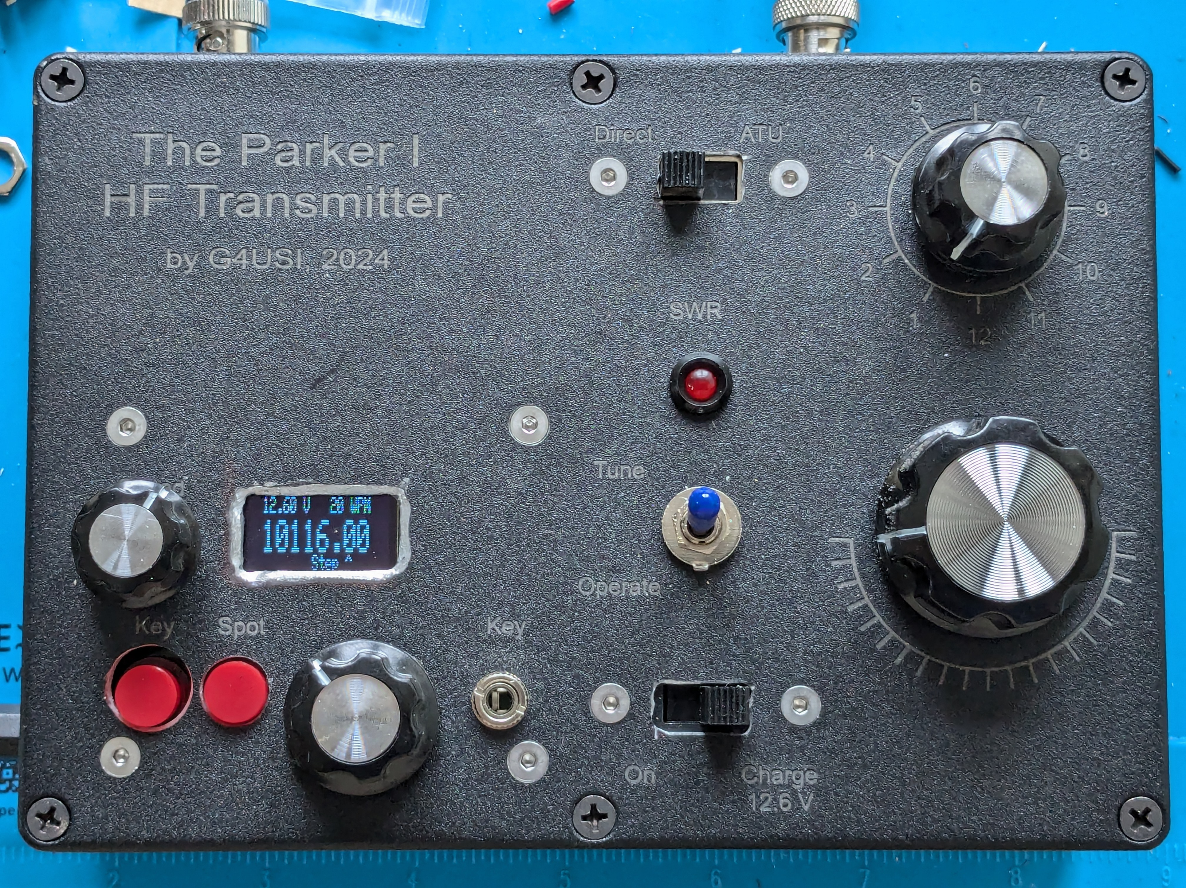

The Parker 1 Portable HF Transmitter

# An entry by Daimon Tilley, G4USI

Member number 15985

# Introduction

Although licensed since 1982, I had a long period away from the hobby (more than 30 years) and returned shortly after my retirement in 2015.

I had never really been into construction before and began my construction and QRP journey in a low-key way in 2018 with construction of a uBitx go-box which I documented in Practical Wireless. Further construction projects followed, including a number of kits from the QRP Labs range, before in about 2020 I went ‘back to basics’ and began to build my first Xtal transmitters.

Meanwhile I had also returned to my other long lost hobby – programming, or coding, and began to experiment with all sorts of Arduino projects.

In 2022 my interest was caught by a QST article from December 2020 entitled the “Tuna Tin ‘S’ – a bare-bones synthesised QRPp transmitter” which used a very basic Arduino VFO as the heart of the rig. Having successfully built the rig, it became the genesis for further experimentation.

My interest in coding meant that I continually, over dozens of versions, refined and improved the basic code, adding huge amounts of functionality.

# Step One - My own VFO

The first real milestone was to create my own VFO board – the “Nano VFO”, **Photos 1 to 4.**

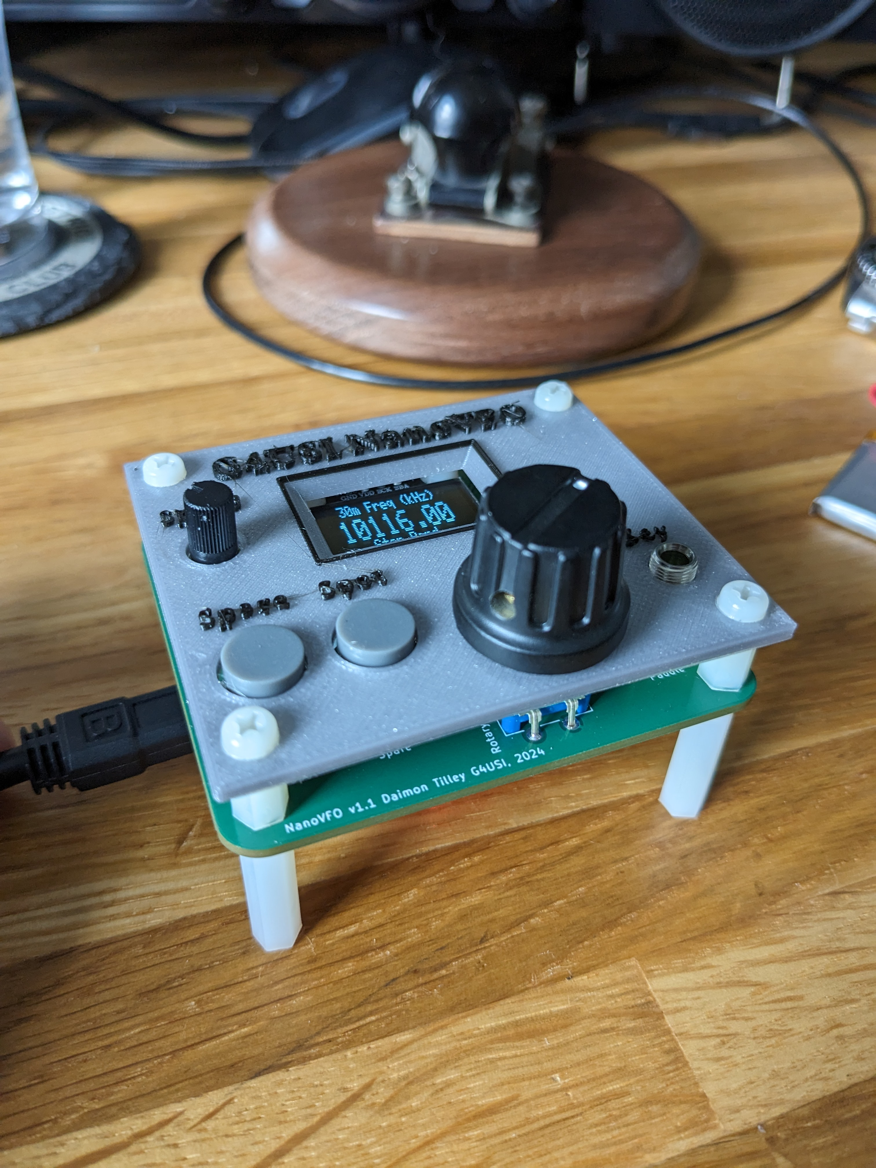

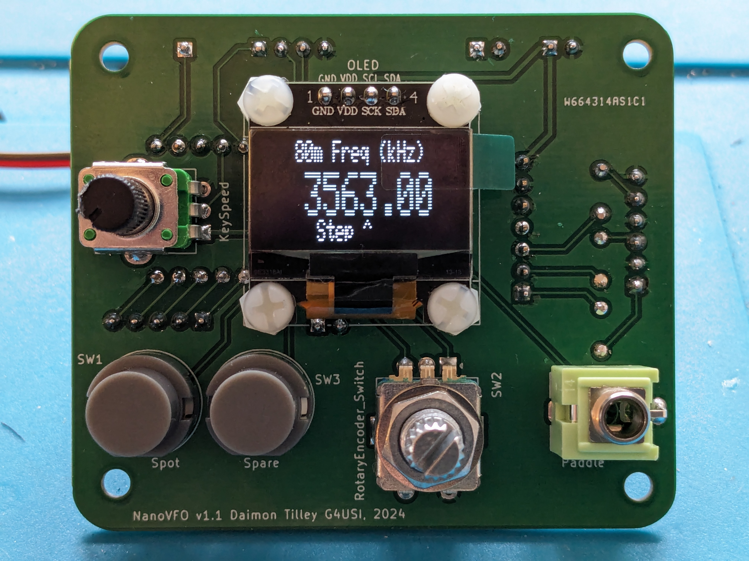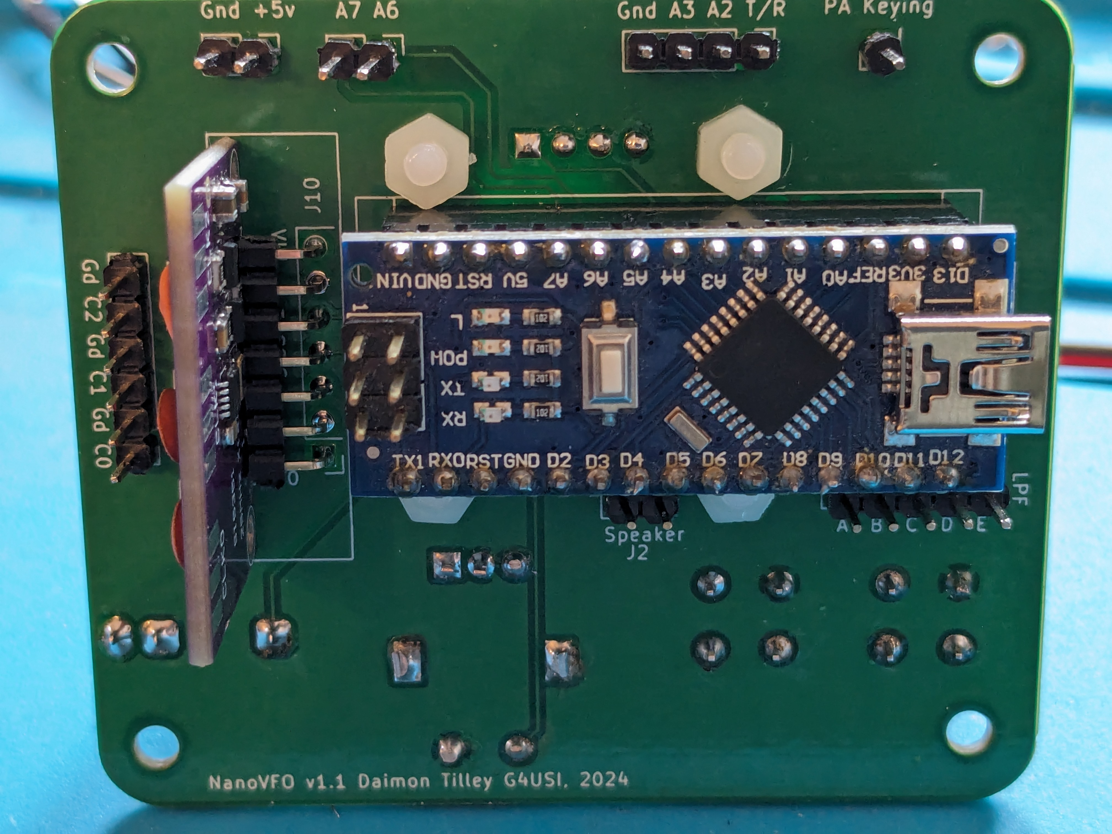

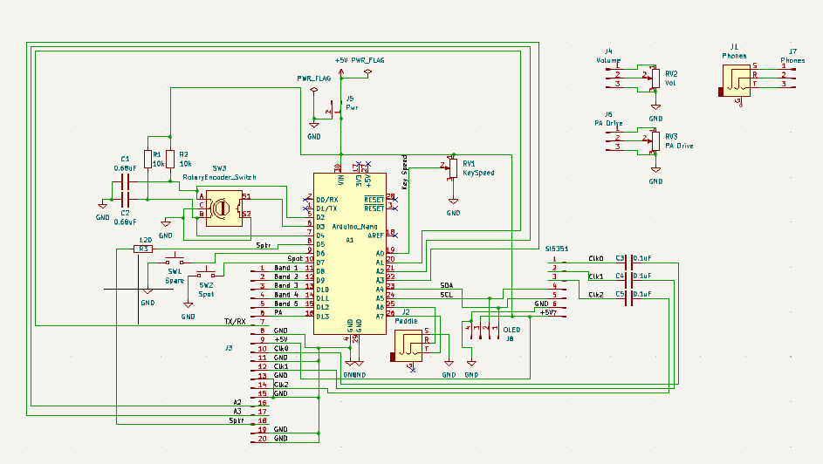

# Step Two - Adding a regulated supply and PA PCB with LPFs

Following the successful PCB design and testing of the VFO, further modifications were made, and a PCB designed for a 5 watt P.A. which, controlled by the Nano VFO also contains 5 Low Pass Filters and the relay switching board from QRPLabs. Additionally, solid state TX / RX switching is also included, and the board is designed so that either and IRF 510 or an RD16HHF1 can be used.

There is the option on the PCB, to leave out the integration of the QRPLabs LPF relay board, and, if doing so there remains an option to include a single LPF of your choice for use on one or two bands. **Photo 5 & 6.**

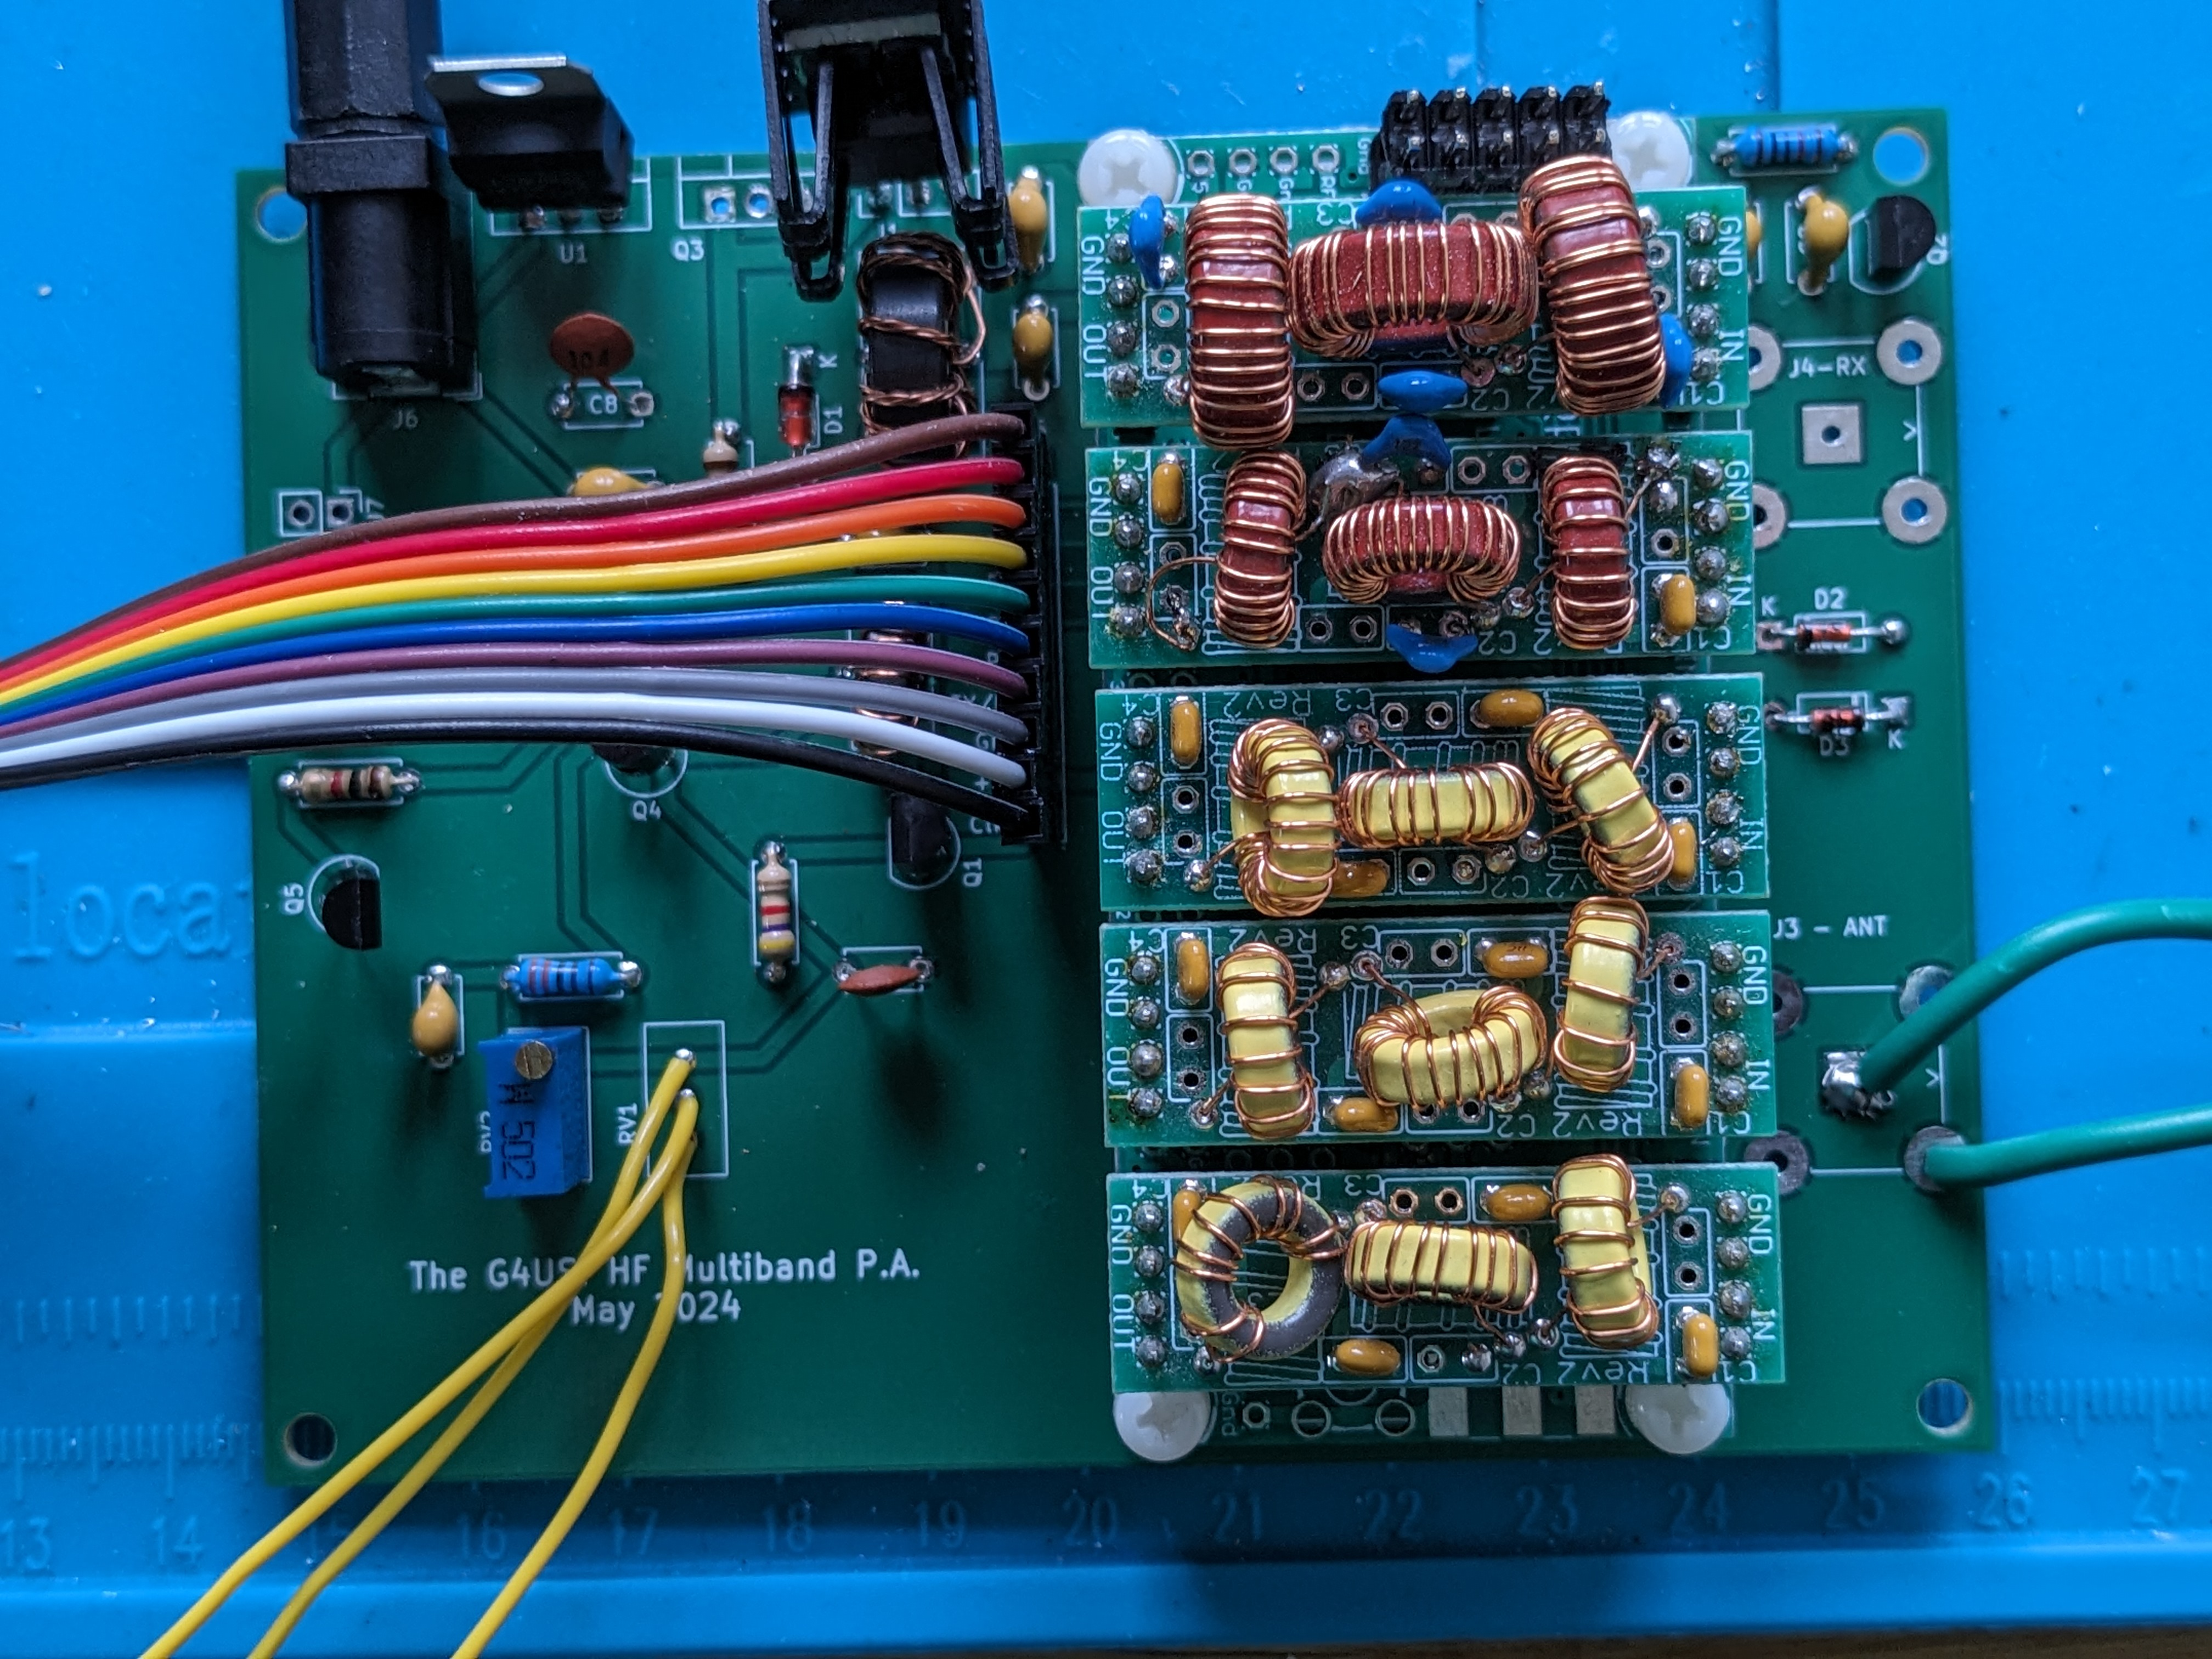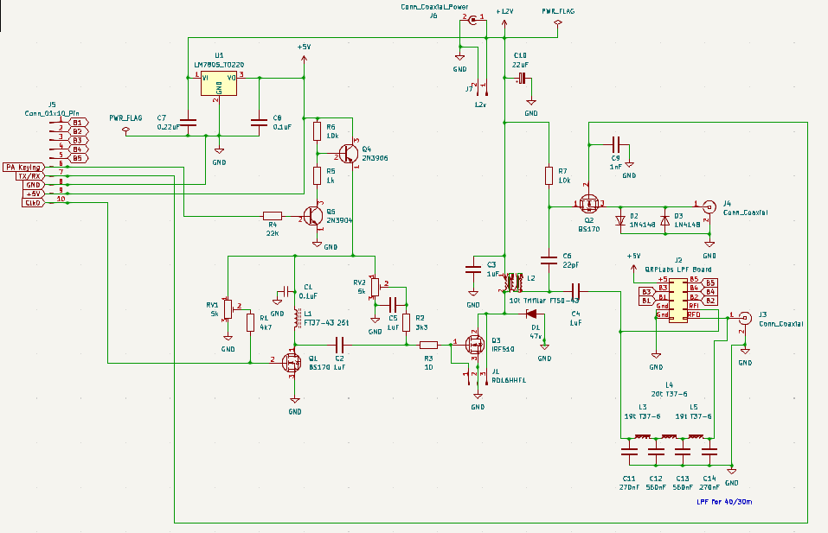

# Step Three – A portable transmitter

The Nano VFO / PA combination worked well. With an IRF510, powers of up to 12 watts were available on the low bands, dropping to a few hundred milliwatts on 10m. To stay QRP legal would require making the driver stage bias pot adjustable from the front panel. However, the use of the RD16HHF1, whilst more expensive, produced a much more even power output without the need to change drive by band. Therefore bias was set for 5w on 160 – 30m, which gave 3.3w on 20m, 2w on 17m and 12m, with 2w on 12m and 1.1 watt on 10m.

I like things in self-contained packages and set myself the task of combining the VFO and PA board, with a home-brew 3S Li-Ion battery pack with BMS, and with an L Match ATU. Basically I just wanted to connect a small receiver and an antenna and begin to operate.

I secured a Hammond black die-cast enclosure, measuring approx. 171 x 121 x 81mm (Hammond 1550EBK). Imagine the size of a thick paperback novel, and that would be about right.

Building the battery pack, and L Match ATU I also included the Kanga Products SWR bridge, as it was already to hand. The rig can be powered by an external supply of 10 – 18 volts or the battery can be switched in to power the rig and be re-charged. The L Match is home brew and can also be switched in or out of circuit as required. Antenna connections are via BNC for the antenna and the RX, which is switched solid state by the VFO. Additional terminal post connections for a wire antenna and counterpoise are also available. Finally a small speaker is included in the front edge of the case for the side-tone.

The whole case was then laser engraved by me to my own design and can be seen in **Photos 6 – 9** during the stages of construction.

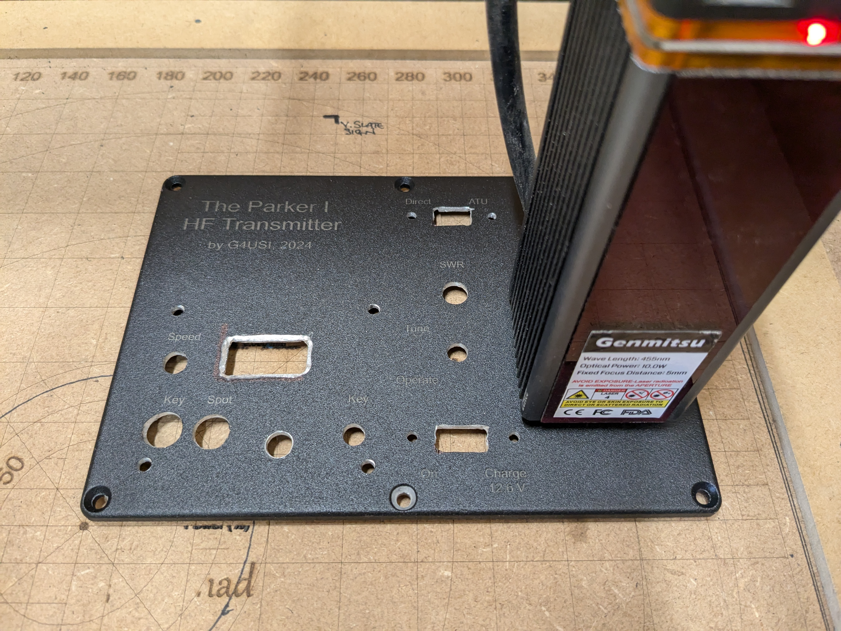

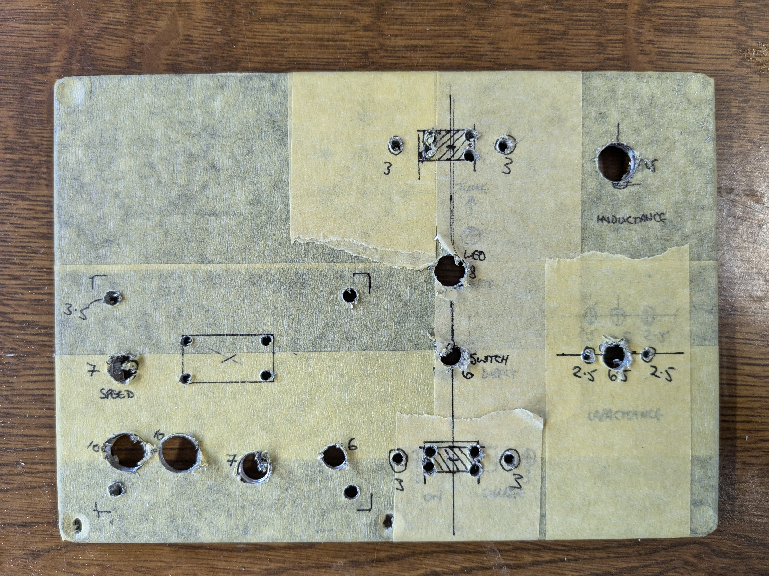

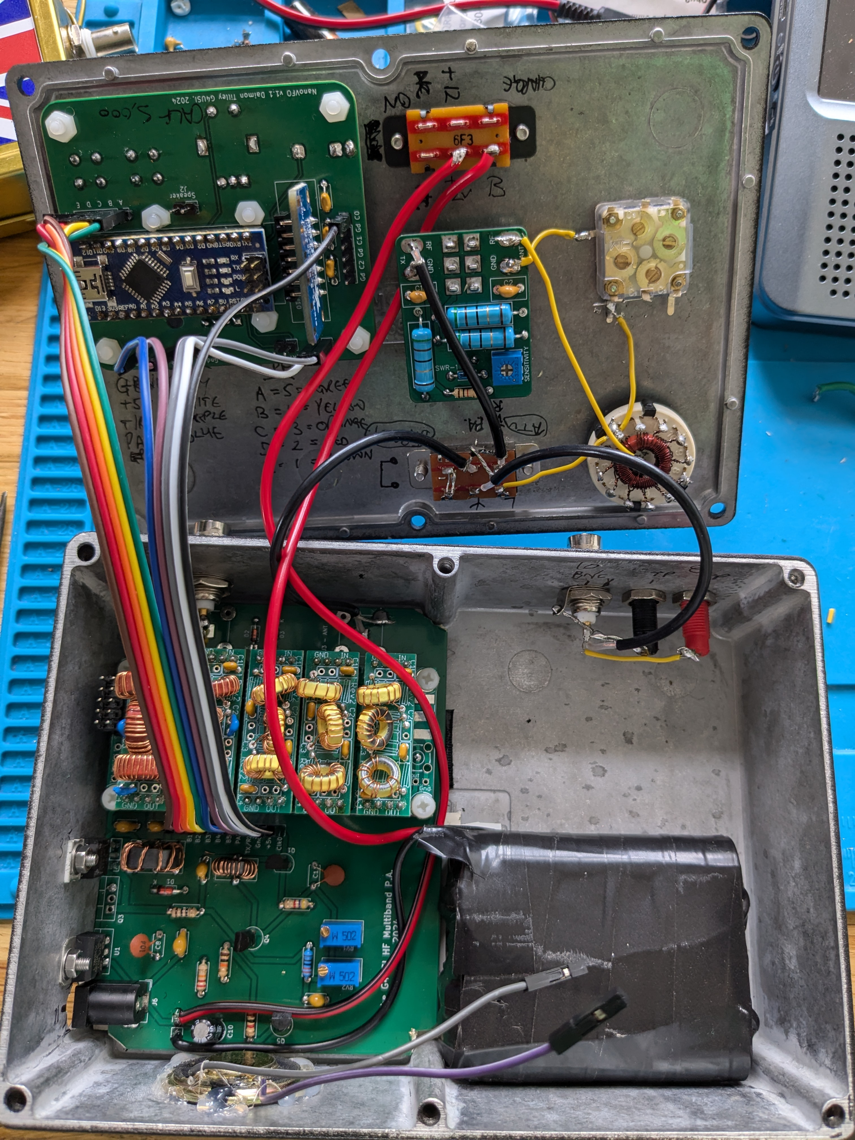



# Step Four – Work in Progress

Whilst the transmitter is entirely complete and has made a good deal of successful CW contacts around the world, paired with either my Belka DX or Malahit receivers, you will see that there is empty space next to the battery pack. In here I plan to include a QRPLabs Tayloe Detector RX module, along with home-brew CW filter and audio amp. This is working on the bench but the filter and audio amp (for which I have designed another PCB) is not yet working to my satisfaction. So at this stage it may or may not be included by the time it comes to judging. None the less, this has proved to be a great learning project and a highly effective base or portable transmitter. Highlights include QSO’s with HS72KING on 40m (6,050 miles) and N2CW on 20m.

# Summary of transmitter features

The project continues to be developed with additional refinements coming frequently, but at the time of writing (September 2024) the feature list is already pretty exhaustive and is listed below and overleaf.

* Regulated 12v supply, offering external power source or use of / and re-charging of internal battery pack.
* Supply voltage indicated on display.
* Ten bands, sharing five Low Pass Filters, as follows:
  + 160 / 80m
  + 60 / 40m
  + 30 / 20m
  + 17 / 15m
  + 12 / 10m
  + Each selected automatically by choosing the band on the VFO, can be shared in parallel for Band Pass Filter switching, in addition, if required.
* Options in code for:
  + External RX
  + Offset for DC RX
  + Offset for Quadrature Receivers
  + Option for Superhet IF
* Selectable VFO tuning steps and no-skip tuning
* Cheap but clear OLED display
* Inbuilt detection of straight / iambic keys on power-up
* Inbuilt straight key
* Inbuilt CW keyer code with speed adjustable by potentiometer and displayed on screen. Any speed is possible but currently coded for 12 – 35 wpm.
* Inbuilt single CW memory keyer for a three by three CQ call (can be interrupted.)
* Full QSK with automated solid state TX / RX switching
* CW side-tone
* SPOT button (without activating PA)
* Automatic switching of PA bias on TX for low RX current consumption
* Spare Arduino pins broken out on VFO board for future use
* Modular construction to allow for additions, replacements and modifications.
* Robust, laser engraved case for a professional look.

# Conclusion

This is my biggest and most complex project to date and I am please about how far I have come in my relatively short construction journey. I hope that you find it worthy of recognition.

Thank you for considering my project.

Daimon Tilley, G4USI.

Member 15985

September 2024.

**ADDITIONAL INFO – On Harmonics measured with Tiny SA 19.11.24..**

|  |  |  |  |
| --- | --- | --- | --- |
| Band | 1st Harmonic | 2nd Harmonic | 3rd Harmonic |
| 160m | -34dB | -58dB | -55dB |
| 80m | -24dB | -61.3dB | - |
| 60m | -52dB | -69dB | -60dB |
| 40m | -30dB | -58.dB | - |
| 30m | -48dB | -55dB | - |
| 20m | -36dB | -63dB | -50dB |
| 17m | -46dB | -46.dB | -42dB |
| 15m | -28dB | -40dB | -40dB |
| 12m | -36dB | -37dB | -42dB |
| 10m | -36dB | -37dB | -32dB |